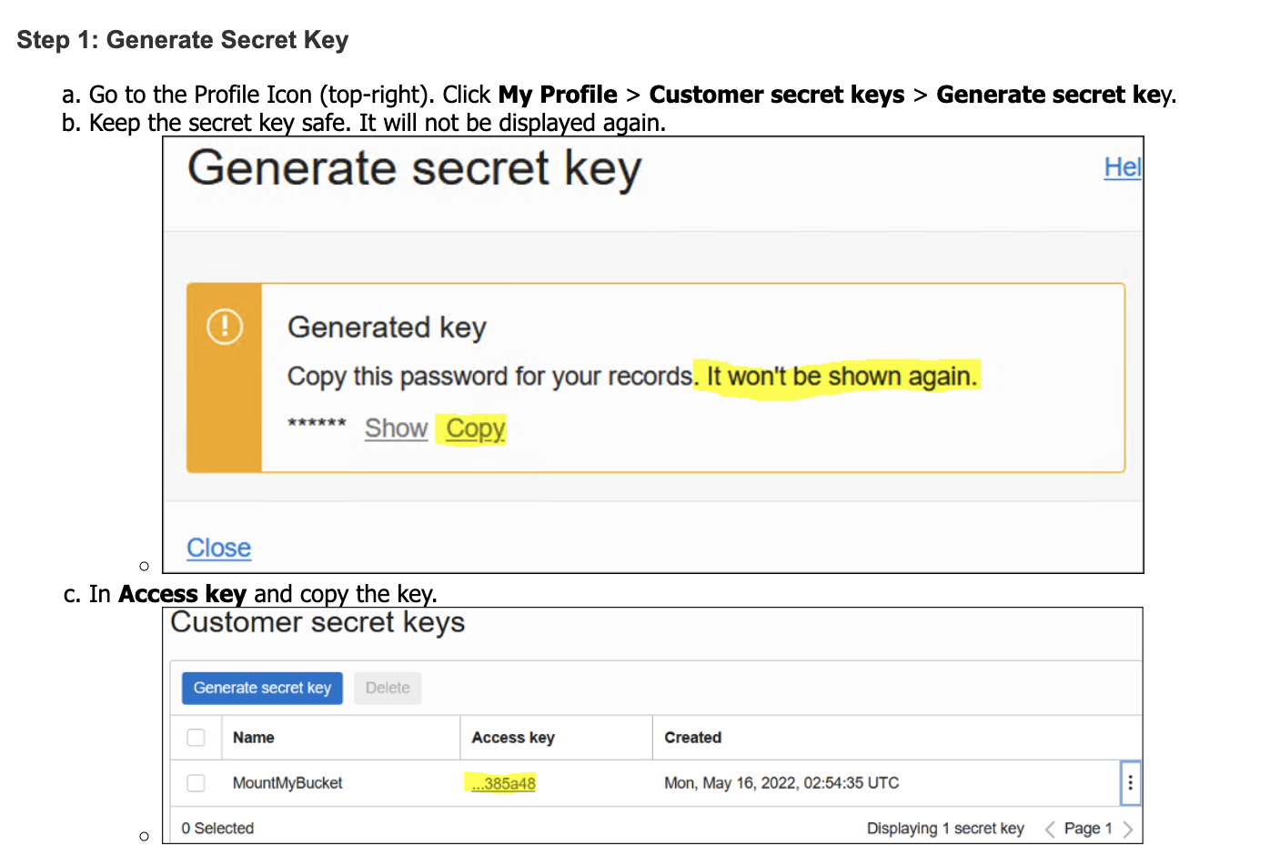

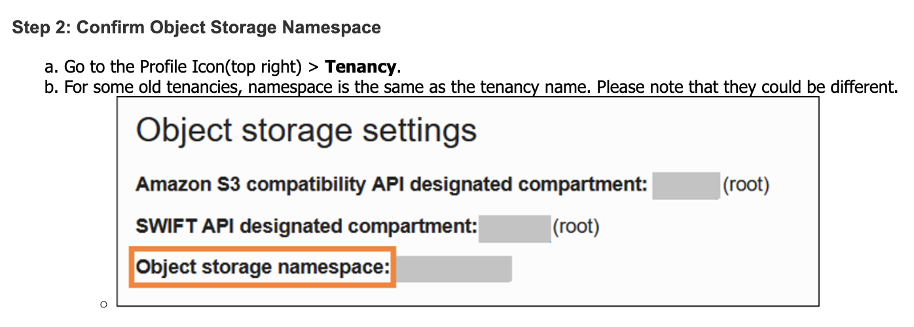

**step 3: Install RCLONE**

1. Run PowerShell as an administrator and enter the following commands to install and configure RCLONE:

mkdir c:\rclone;

cd c:\rclone

[Net.ServicePointManager]::SecurityProtocol = [Net.SecurityProtocolType]::Tls12

Invoke-WebRequest -Uri "https://downloads.rclone.org/v1.53.0/rclone-v1.53.0-windows-amd64.zip" -OutFile "c:\rclone\rclone.zip"

Expand-Archive -path 'c:\rclone\rclone.zip' -destinationpath '.\'

cp c:\rclone\rclone-v1.53.0-windows-amd64\* c:\rclone\

rm -r c:\rclone\rclone-v1.53.0-windows-amd64; rm -r c:\rclone\rclone.zip

1. Complete the configuration as shown below:

.\rclone.exe config

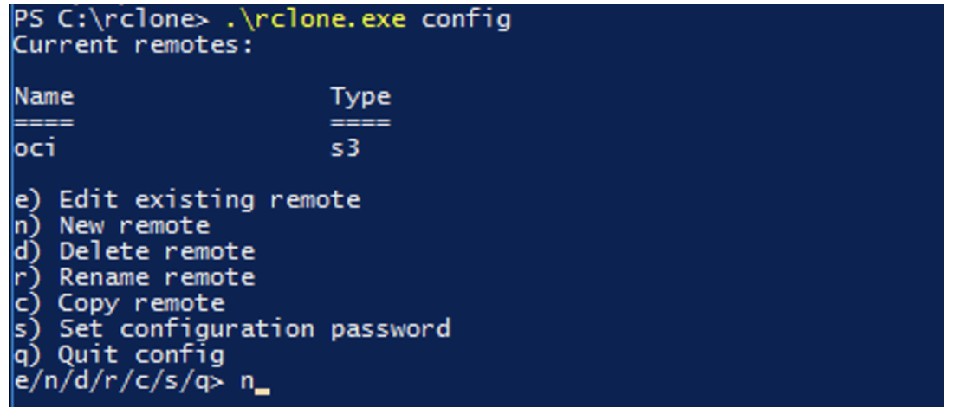

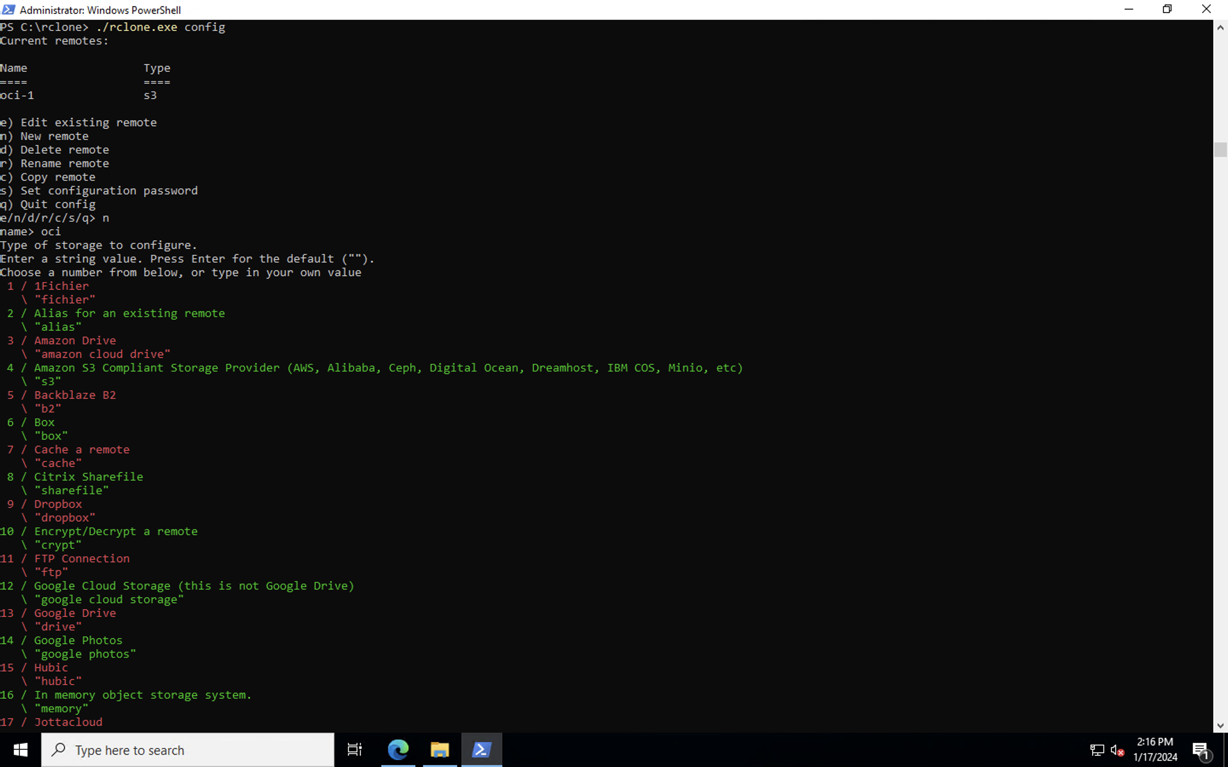

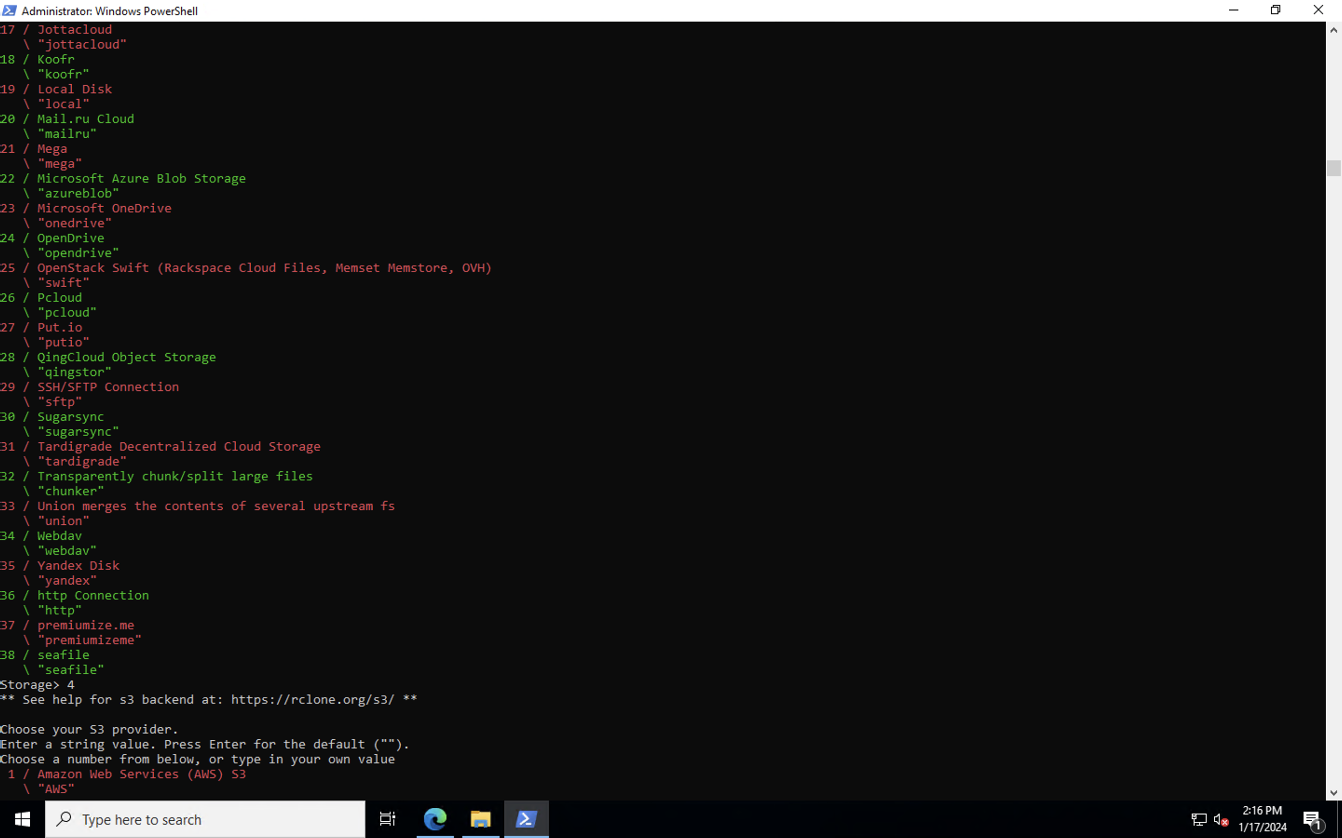

e/n/d/r/c/s/q> n

**name> oci**

Type of storage to configure.

Enter a string value. Press Enter for the default ("").

Choose a number from below, or type in your own value

1 / 1Fichier

\ "fichier"

2 / Alias for an existing remote

\ "alias"

3 / Amazon Drive

\ "amazon cloud drive"

**4 / Amazon S3 Compliant Storage Provider (AWS, Alibaba, Ceph, Digital Ocean, Dreamhost, IBM COS, Minio, etc)**

**\ "s3"**

5 / Backblaze B2

\ "b2"

6 / Box

\ "box"

7 / Cache a remote

\ "cache"

8 / Citrix Sharefile

\ "sharefile"

9 / Dropbox

\ "dropbox"

10 / Encrypt/Decrypt a remote

\ "crypt"

11 / FTP Connection

\ "ftp"

12 / Google Cloud Storage (this is not Google Drive)

\ "google cloud storage"

13 / Google Drive

\ "drive"

14 / Google Photos

\ "google photos"

15 / Hubic

\ "hubic"

16 / In memory object storage system.

\ "memory"

17 / Jottacloud

\ "jottacloud"

18 / Koofr

\ "koofr"

19 / Local Disk

\ "local"

20 / Mail.ru Cloud

\ "mailru"

21 / Mega

\ "mega"

22 / Microsoft Azure Blob Storage

\ "azureblob"

23 / Microsoft OneDrive

\ "onedrive"

24 / OpenDrive

\ "opendrive"

25 / OpenStack Swift (Rackspace Cloud Files, Memset Memstore, OVH)

\ "swift"

26 / Pcloud

\ "pcloud"

27 / Put.io

\ "putio"

28 / QingCloud Object Storage

\ "qingstor"

29 / SSH/SFTP Connection

\ "sftp"

30 / Sugarsync

\ "sugarsync"

31 / Tardigrade Decentralized Cloud Storage

\ "tardigrade"

32 / Transparently chunk/split large files

\ "chunker"

33 / Union merges the contents of several upstream fs

\ "union"

34 / Webdav

\ "webdav"

35 / Yandex Disk

\ "yandex"

36 / http Connection

\ "http"

37 / premiumize.me

\ "premiumizeme"

38 / seafile

\ "seafile"

**Storage>4**

** See help for s3 backend at: https://rclone.org/s3/ **

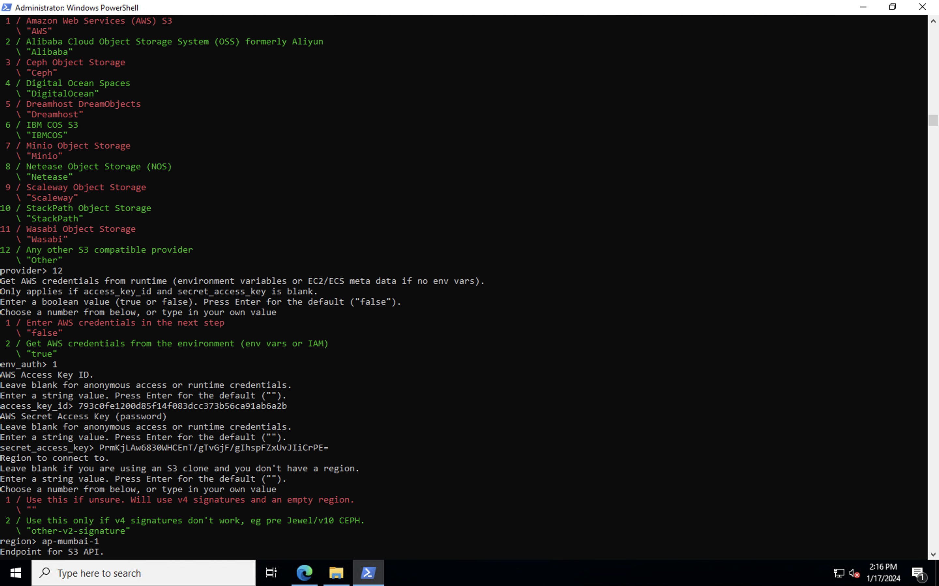

Choose your S3 provider.

Enter a string value. Press Enter for the default ("").

Choose a number from below, or type in your own value

1 / Amazon Web Services (AWS) S3

\ "AWS"

2 / Alibaba Cloud Object Storage System (OSS) formerly Aliyun

\ "Alibaba"

3 / Ceph Object Storage

\ "Ceph"

4 / Digital Ocean Spaces

\ "DigitalOcean"

5 / Dreamhost DreamObjects

\ "Dreamhost"

6 / IBM COS S3

\ "IBMCOS"

7 / Minio Object Storage

\ "Minio"

8 / Netease Object Storage (NOS)

\ "Netease"

9 / Scaleway Object Storage

\ "Scaleway"

10 / StackPath Object Storage

\ "StackPath"

11 / Wasabi Object Storage

\ "Wasabi"

12 / Any other S3 compatible provider

\ "Other"

**provider>12**

Get AWS credentials from runtime (environment variables or EC2/ECS meta data if no env vars).

Only applies if access_key_id and secret_access_key is blank.

Enter a boolean value (true or false). Press Enter for the default ("false").

Choose a number from below, or type in your own value

1 / Enter AWS credentials in the next step

\ "false"

2 / Get AWS credentials from the environment (env vars or IAM)

\ "true"

**env_auth> 1**

AWS Access Key ID.

Leave blank for anonymous access or runtime credentials.

Enter a string value. Press Enter for the default ("").

**access_key_id> 793c0fe1200d85f14f083dcc373b56ca91ab6a2b**

AWS Secret Access Key (password)

Leave blank for anonymous access or runtime credentials.

Enter a string value. Press Enter for the default ("").

**secret_access_key> PrmKjLAw6830WHCEnT/gTvGjF/gIhspFZxUvJIiCrPE=**

Region to connect to.

Leave blank if you are using an S3 clone and you don't have a region.

Enter a string value. Press Enter for the default ("").

Choose a number from below, or type in your own value

1 / Use this if unsure. Will use v4 signatures and an empty region.

\ ""

2 / Use this only if v4 signatures don't work, eg pre Jewel/v10 CEPH.

\ "other-v2-signature"

**region> ap-mumbai-1**

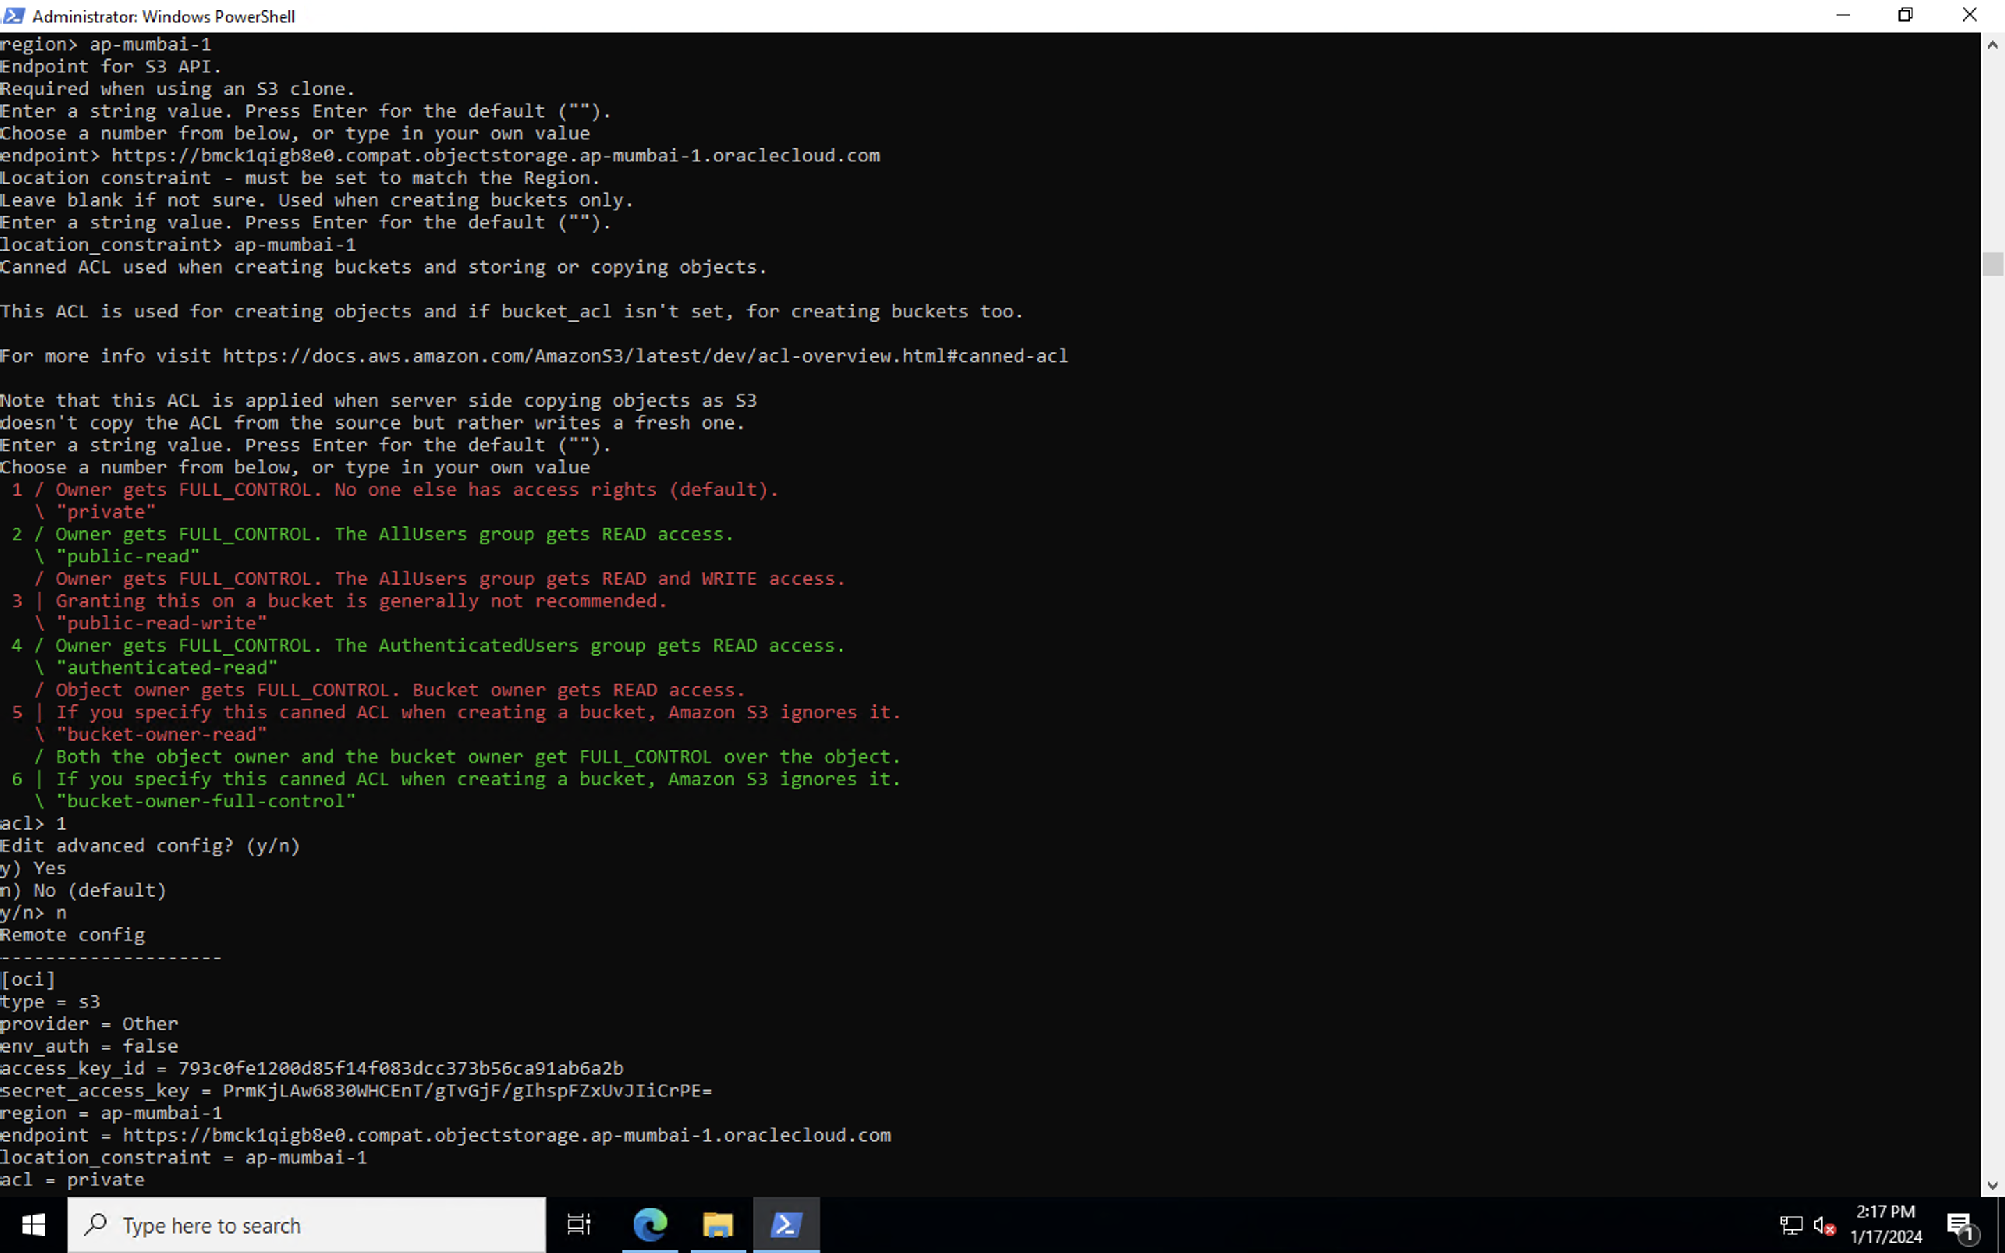

**For API endpoint refer to :** [**https://docs.oracle.com/en-us/iaas/api/**](https://docs.oracle.com/en-us/iaas/api/)

Endpoint for S3 API.

Required when using an S3 clone.

Enter a string value. Press Enter for the default ("").

Choose a number from below, or type in your own value

**endpoint> https://bmck1qigb8e0.compat.objectstorage.ap-mumbai-1.oraclecloud.com**

Location constraint - must be set to match the Region.

Leave blank if not sure. Used when creating buckets only.

Enter a string value. Press Enter for the default ("").

**location_constraint> ap-mumbai-1**

Canned ACL used when creating buckets and storing or copying objects.

This ACL is used for creating objects and if bucket_acl isn't set, for creating buckets too.

For more info visit https://docs.aws.amazon.com/AmazonS3/latest/dev/acl-overview.html#canned-acl

Note that this ACL is applied when server side copying objects as S3

doesn't copy the ACL from the source but rather writes a fresh one.

Enter a string value. Press Enter for the default ("").

Choose a number from below, or type in your own value

1 / Owner gets FULL_CONTROL. No one else has access rights (default).

\ "private"

2 / Owner gets FULL_CONTROL. The AllUsers group gets READ access.

\ "public-read"

/ Owner gets FULL_CONTROL. The AllUsers group gets READ and WRITE access.

3 | Granting this on a bucket is generally not recommended.

\ "public-read-write"

4 / Owner gets FULL_CONTROL. The AuthenticatedUsers group gets READ access.

\ "authenticated-read"

/ Object owner gets FULL_CONTROL. Bucket owner gets READ access.

5 | If you specify this canned ACL when creating a bucket, Amazon S3 ignores it.

\ "bucket-owner-read"

/ Both the object owner and the bucket owner get FULL_CONTROL over the object.

6 | If you specify this canned ACL when creating a bucket, Amazon S3 ignores it.

\ "bucket-owner-full-control"

**acl> 1**

Edit advanced config? (y/n)

y) Yes

n) No (default)

**y/n> n**

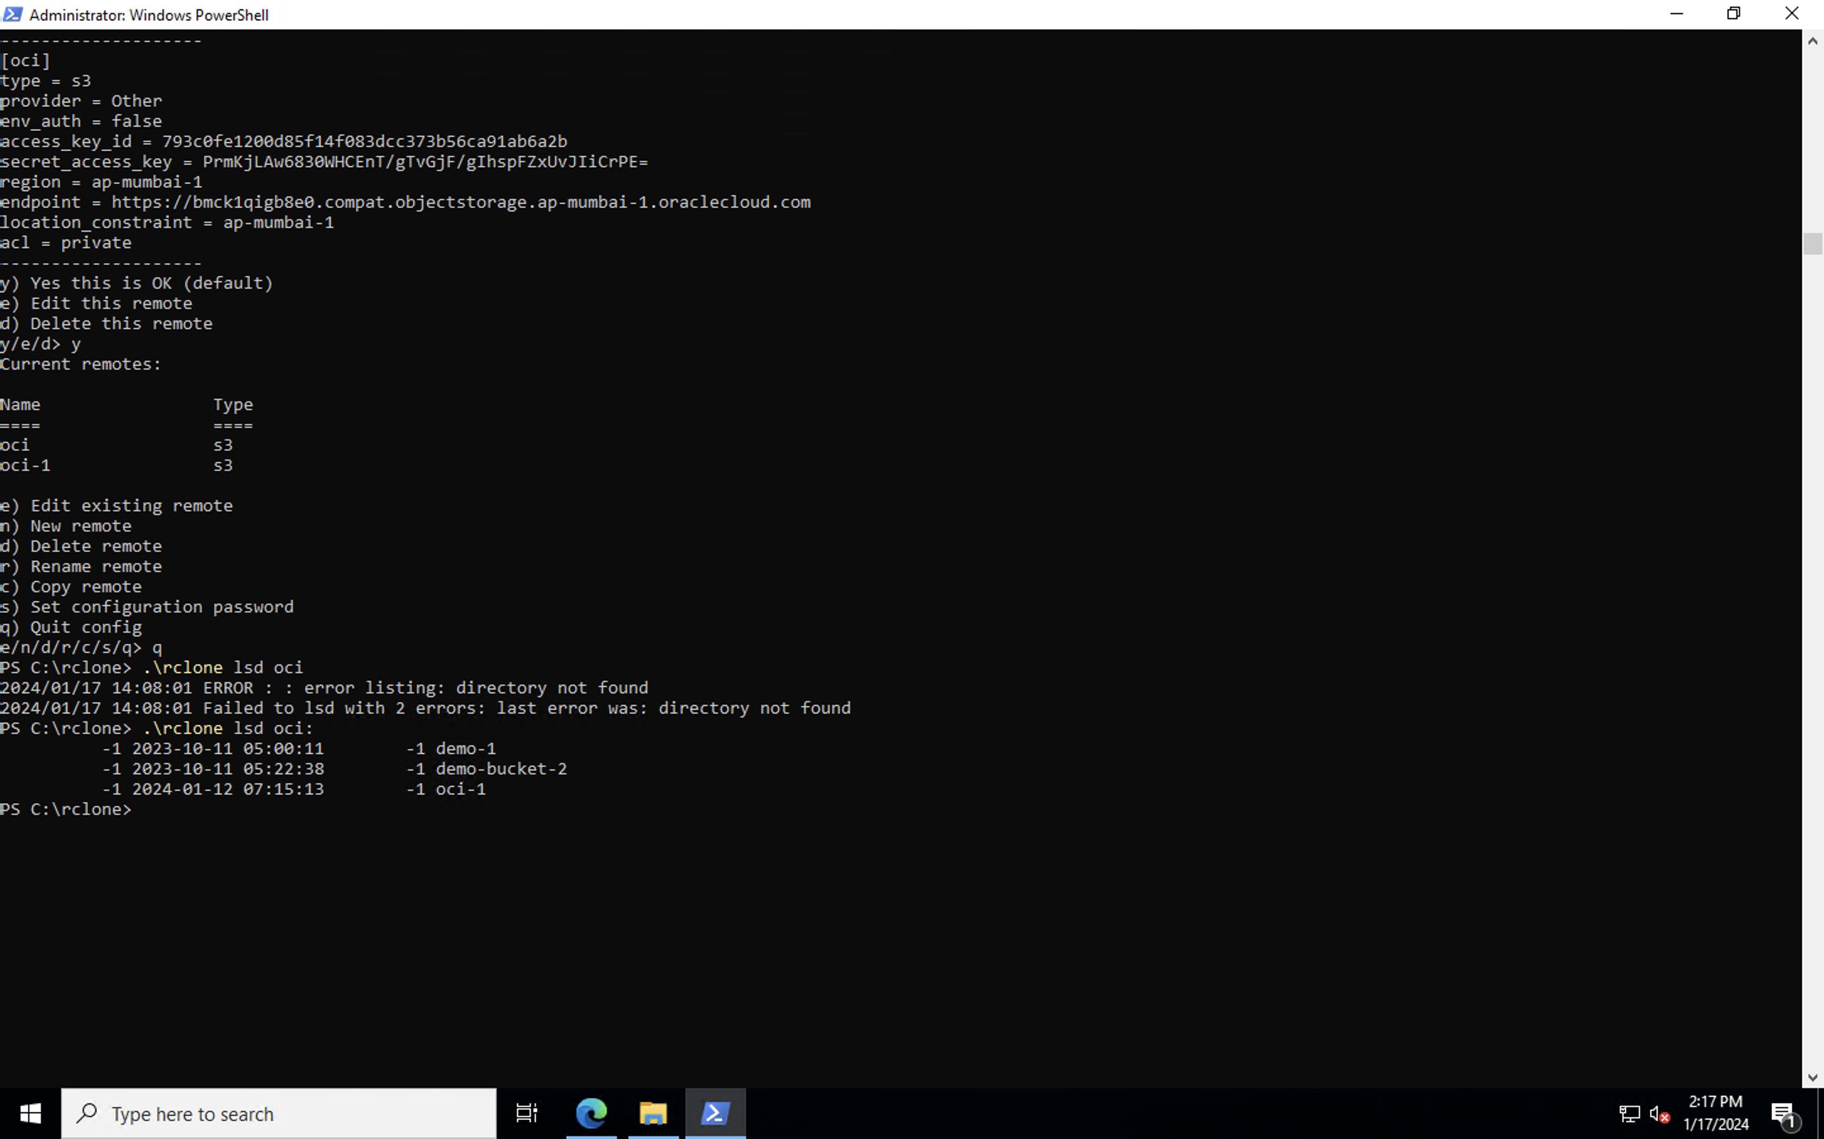

Remote config

--------------------

[oci]

type = s3

provider = Other

env_auth = false

access_key_id = 793c0fe1200d85f14f083dcc373b56ca91ab6a2b

secret_access_key = PrmKjLAw6830WHCEnT/gTvGjF/gIhspFZxUvJIiCrPE=

region = ap-mumbai-1

endpoint = https://bmck1qigb8e0.compat.objectstorage.ap-mumbai-1.oraclecloud.com

location_constraint = ap-mumbai-1

acl = private

--------------------

y) Yes this is OK (default)

e) Edit this remote

d) Delete this remote

**y/e/d> y**

Current remotes:

Name Type

==== ====

oci s3

oci-1 s3

e) Edit existing remote

n) New remote

d) Delete remote

r) Rename remote

c) Copy remote

s) Set configuration password

q) Quit config

**e/n/d/r/c/s/q> q**

1. Install the required tools:

Set-ExecutionPolicy Bypass -Scope Process -Force; [System.Net.ServicePointManager]::SecurityProtocol = [System.Net.ServicePointManager]::SecurityProtocol -bor 3072; iex ((New-Object  System.Net.WebClient).DownloadString('https://chocolatey.org/install.ps1'))

choco install winfsp -y

Invoke-WebRequest -Uri "https://nssm.cc/release/nssm-2.24.zip" -OutFile "c:\rclone\nssm.zip"

Expand-Archive -path 'c:\rclone\nssm.zip' -destinationpath '.\'

cp .\nssm-2.24\win64\nssm.exe .\

rm nssm.zip

 rm -r .\nssm-2.24\

PS C:\rclone> .\rclone lsd oci

2024/01/17 14:08:01 ERROR : : error listing: directory not found

2024/01/17 14:08:01 Failed to lsd with 2 errors: last error was: directory not found

PS C:\rclone> **.\rclone lsd oci:**

-1 2023-10-11 05:00:11 -1 demo-1

-1 2023-10-11 05:22:38 -1 demo-bucket-2

-1 2024-01-12 07:15:13 -1 oci-1

PS C:\rclone> **.\rclone.exe mount oci: Y:**

Reference video for configuration : https://www.youtube.com/watch?v=2ZivVxg6tio&t=1192s